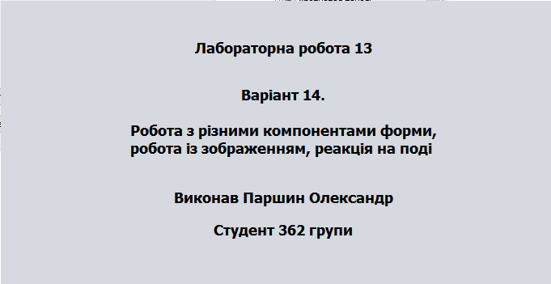

/\*

\*/

package Lab13;

import java.awt.Image;

import javax.swing.ImageIcon;

import javax.swing.JLabel;

;

/\*\*

\*

\* @author parsh

\*/

public class lab13 extends javax.swing.JFrame {

/\*\*

\* Creates new form lab13

\*/

private javax.swing.JLabel imageLabel1;

private javax.swing.JLabel imageLabel2;

public void downloadImage()

{

imageLabel1 = new JLabel("");

Image img = new ImageIcon(this.getClass().getResource("/lyra.png")).getImage();

imageLabel1.setIcon(new ImageIcon(img));

imageLabel1.setBounds(0, 0, 128, 128);

jPanel1.add(imageLabel1);

imageLabel2 = new JLabel("");

img = new ImageIcon(this.getClass().getResource("/darth.png")).getImage();

imageLabel2.setIcon(new ImageIcon(img));

imageLabel2.setBounds(0, 0, 128, 128);

jPanel1.add(imageLabel2);

imageLabel1.setVisible(false);

imageLabel2.setVisible(false);

}

public lab13() {

initComponents();

jLabel1.setText("Паршин"); jLabel1.setVisible(false);

jLabel2.setText("Александр"); jLabel2.setVisible(false);

jLabel3.setText("362"); jLabel3.setVisible(false);

jLabel4.setText("Даля хх"); jLabel4.setVisible(false);

downloadImage();

}

private void jButton2ActionPerformed(java.awt.event.ActionEvent evt) {

// TODO add your handling code here:

if(jLabel2.isVisible())jLabel2.setVisible(false);

else jLabel2.setVisible(true);

}

private void jButton1ActionPerformed(java.awt.event.ActionEvent evt) {

// TODO add your handling code here:

if(jLabel1.isVisible())jLabel1.setVisible(false);

else jLabel1.setVisible(true);

}

private void jButton3ActionPerformed(java.awt.event.ActionEvent evt) {

// TODO add your handling code here:

if(jLabel3.isVisible())jLabel3.setVisible(false);

else jLabel3.setVisible(true);

}

private void jButton4ActionPerformed(java.awt.event.ActionEvent evt) {

// TODO add your handling code here:

if(jLabel4.isVisible())jLabel4.setVisible(false);

else jLabel4.setVisible(true);

}

private void jButton5ActionPerformed(java.awt.event.ActionEvent evt) {

// TODO add your handling code here:

System.exit(0);

}

private void jButton6ActionPerformed(java.awt.event.ActionEvent evt) {

// TODO add your handling code here:

imageLabel1.setVisible(true);

imageLabel2.setVisible(false);

}

private void jButton7ActionPerformed(java.awt.event.ActionEvent evt) {

// TODO add your handling code here:

imageLabel2.setVisible(true);

imageLabel1.setVisible(false);

}

/\*\*

\* @param args the command line arguments

\*/

public static void main(String args[]) {

/\* Create and display the form \*/

java.awt.EventQueue.invokeLater(new Runnable() {

public void run() {

//new lab13().setVisible(true);

}

});

}

public static void Visible(boolean a)

{

new lab13().setVisible(a);

}

// Variables declaration - do not modify

private javax.swing.JButton jButton1;

private javax.swing.JButton jButton2;

private javax.swing.JButton jButton3;

private javax.swing.JButton jButton4;

private javax.swing.JButton jButton5;

private javax.swing.JButton jButton6;

private javax.swing.JButton jButton7;

private javax.swing.JLabel jLabel1;

private javax.swing.JLabel jLabel2;

private javax.swing.JLabel jLabel3;

private javax.swing.JLabel jLabel4;

private javax.swing.JPanel jPanel1;

// End of variables declaration

}

